# Computer Vision Hw1 Report

* Discription
  + 1. Use B_PIX to write a program to generate

(a) upside-down lena.im

(b) right-side-left lena.im

(c) diagonally mirrored lena.im

* + 2. Use Photoshop to

(a) rotate lena.im 45 degrees clockwise

(b) shrink lena.im in half

(c) binarize lena.im at 128 to get a binary image

* + java code , eclipse project
  + input : put lena.bmp in the folder “input”
  + output : result folder “output”
  + photoshop 6.1
* Algorithm
  + Up Side Down
    - Step1.取得圖片的RGB Matrix
    - Step2.對每一個 Column,由外向內Swap首尾兩個Pixel的RGB值
  + Right Side Left
    - 同Up Side Down但Row , Col處理順序互換
  + Diagonally Mirror
    - Switch row and column
* Parameters (if any)
  + no
* Principal Code Fragment

main() (src/hw1/BasicImageManipulation.java)

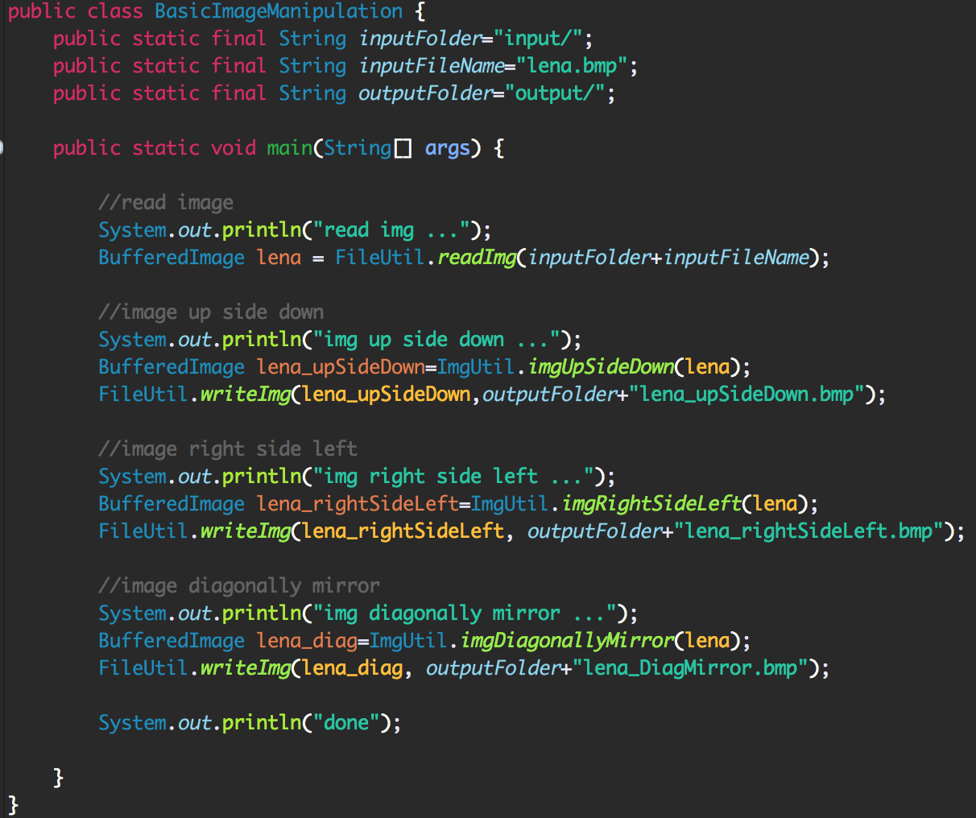

Function Up Side Down (src/cv1.util.cv/ImgUtil.java)

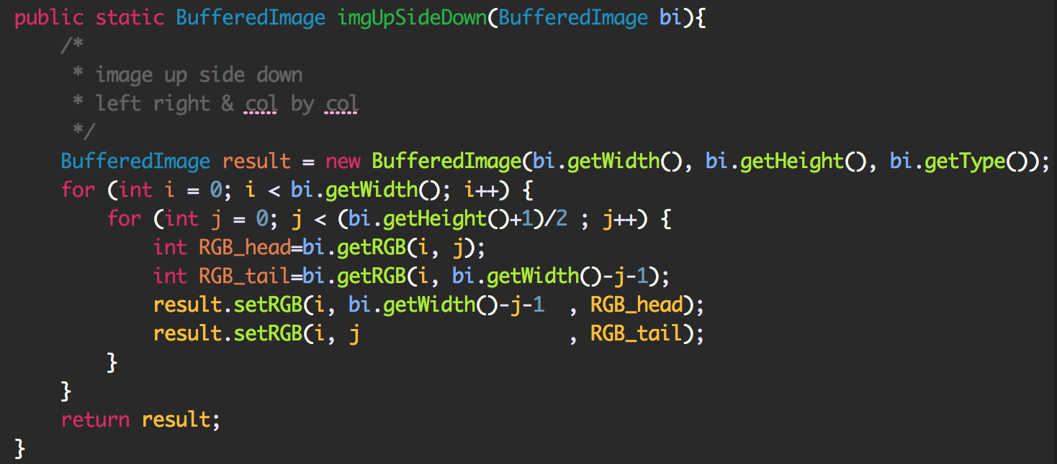

Function Right Side Left (src/cv1.util.cv/ImgUtil.java)

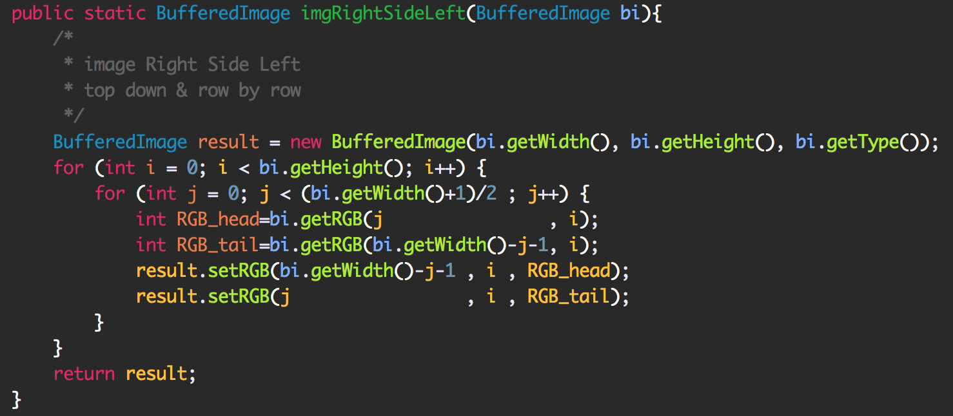

Function Diagonally Mirrored (src/cv1.util.cv/ImgUtil.java)

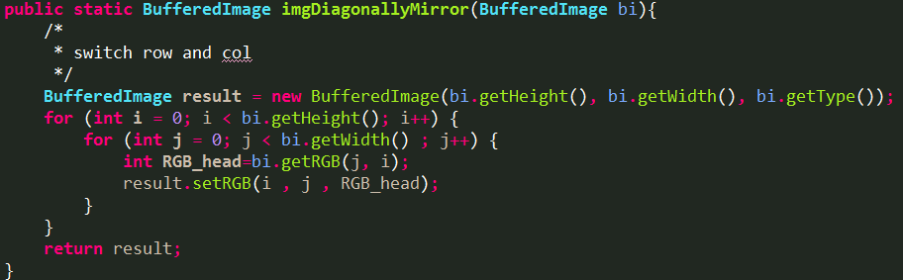

* Resulting Images
  + Program Result
    - Up Side Down

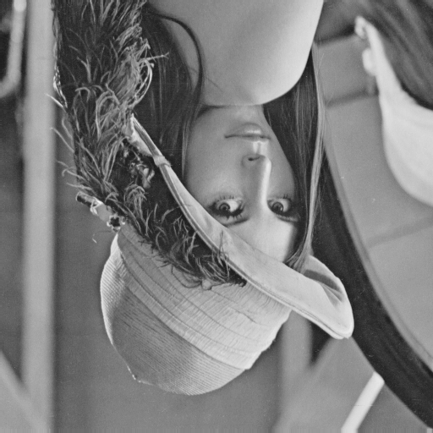

* + - Right Side Left

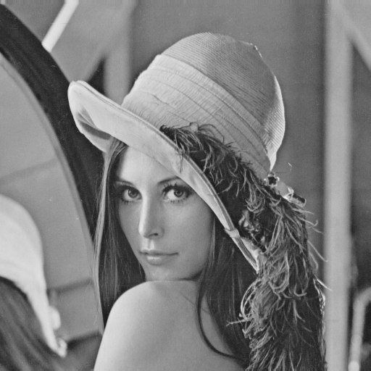

* + - Diagonally Mirrored



* + Photoshop Result (photoshop 6.1)
    - Rotate (step:影像 -> 影像旋轉 -> 任意 -> 45度)



* + - Shrink Half (step:影像 -> 影像尺寸 -> 寬度&高度256)



* + - Binarize (step:影像 -> 調整 -> 臨界值 -> 128)

